White Paper on Climate Change, Carbon Capture and Environmental Justice

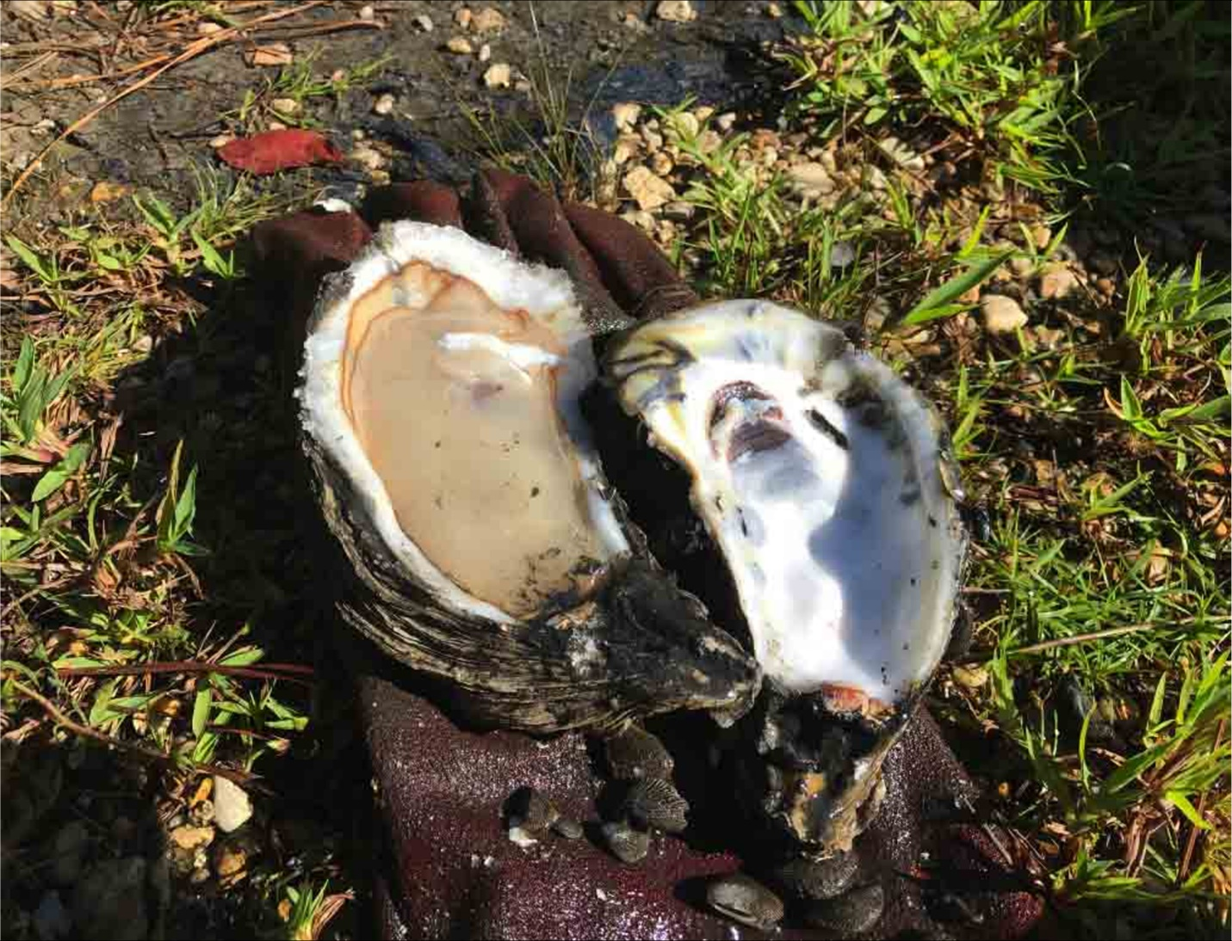
Figure 1
Author: William Burton Fears, M.D., F.A.C.P
Date: 5/13/2022

Table of Contents

Page 3. Goals and Purposes
Page 4. General Concepts
Page 7. Background
Page 9. Outputs
Page 13. Shell Formation
Page 18. Sustainability, Social License, and Environmental Justice
Page 26. Action Plan
Page 29. Bibliography

Goals and Purposes
Envirohome Earth is a scientific team whose approach is focused on those organisms in the Ocean that form calcium carbonate in quantities practical for the sequestration of Gigatons of CO₂/yr. We summarize a two-pronged approach to maximize the removal using the Ocean life that makes shell (calcifiers) to remove CO₂ from the atmosphere. The first and most important approach is a massive effort aimed at restoring Oyster reefs and providing shoreline habitat for corals, crabs, shrimp, plankton, and other calcifying shellfish. This is because 90% of many of these creatures have been eliminated from the worlds’ shoreline habitat.
Second, we plan to examine the possible benefits of ocean alkalinization and other modalities.
Importantly, it does not matter if a citizen does or doesn’t like Oysters, their harvest can be used as a source of high-quality supplements and feed for other animals and has unsaturated fat and is high in omega-3 fatty acids.
Most importantly, is that this elegant model for the removal of Carbon Dioxide should be embraced by all political parties. Who would not want to reestablish our shorelines?
General Concepts

Our two-pronged approach aims to maximize the removal of CO₂ using the Ocean to remove CO₂ from the atmosphere. First, Ocean calcifiers form calcium carbonate / limestone in their shells using CO₂ from the atmosphere in equilibrium with the surface Ocean. As the shellfish cultivation industry is one of the few industries that can increase the amount of Carbon capture exponentially while being sensitive to Ocean Ecosystems, we propose establishing essential infrastructure to change the aquaculture paradigm so that shellfish producers greatly expand production specifically to generate more shell. Established oyster beds/reefs were fished out in the 18th and 19th centuries by dredging to harvest oysters as cheap human food for the growing cities of North America and Europe. By the early 1900’s, 90% of oyster beds had been fished out. At that time New Yorker’s ate 300 Oysters per year purchased on the street. Now they eat 3 per year because they are expensive and rare. Production was also diminished for both fisheries and Oysters by sewage outflows and oil spills. Clearly, a large part of the decline in production is also due to the habit of not returning the shell into the Ocean to provide the natural alkalinization and structure for new shell formation. Shell has been used for road construction, landfill, and calcium feed supplement. We propose to establish essential infrastructure (foundations, government funding, other NGO’s) designed to change the paradigm to re-establish the reefs and the bivalve population.
Second, we propose a test of artificial (local at first) alkalinization to see if this enhances the amount of shell, and hence the amount of CO₂ that is sequestered. Dr. Rebecca Albright showed in an article in Nature, Vol 531, 17th of March 2016 that Reversal of ocean acidification enhances net coral reef calcification. Acidification induced reductions in calcification are projected to shift coral reefs from a state of net accretion to one of net dissolution this century. Dr. Albright was able to show that restoration of pH closer to pre-industrial conditions resulted in net community calcification using controlled release of sodium hydroxide onto coral reefs. She was able to show a net increase in aragonite (calcium carbonate) by the release of controlled concentrations of sodium hydroxide into a small estuary. Our team, using guidelines from this paper and others, would like to investigate further the role of additional alkalinization to see if it would add further benefit from current levels of calcification.
Our primary goal is the re-establishment of coastal systems in the United States and in the World at large. The issue of alkalinization needs to be investigated further but the re-establishment of coastal systems is the most important step that the world can take to mitigate climate change because much of the infrastructure is already in place.

Background

Input 1 (juvenile animals): The farming cycle begins with the collection of larvae, which may be gathered in the wild or produced in farm hatcheries (depending on the species and location). Oyster larvae are kept suspended in tanks by circulating water until they transform into oyster spat or oyster seed. [Clam larvae are kept in hatchery tanks where they transform into seed; Mussel larvae transform to juvenile animals; Scallop larvae settle and become juvenile animals]. Farmers acquire clam and oyster seed at various stages of its development, depending on the requirements of their operation. The seed is put into a nursery environment where it is nurtured into juvenile animals. The juvenile animals then graduate to the grow out phase of their development during which they mature to marketable size.
Input 2 (hardware facilities):
- ON SHORE industrial plant to treat, store and transport the harvested shellfish (refrigeration, road transport, etc). Temperature-controlled hatcheries. Electricity consumption of onshore facilities is the principal carbon cost/environmental burden of cultivating bivalves.
- OFFSHORE fishing vessels to manage and harvest the farms (still powered by diesel fuel, so these are the major contributors to the carbon cost burden). Offshore floating (licenced) aquaculture farms (called tenures in British Columbia) according to species. [Mussels are relocated to deep water tenures where they are suspended on ‘ropes’ or in mesh ‘socks’ to mature to marketable size over a period of 18 to 36 months. Oyster juveniles are moved to cages through which ocean water is circulated around trays of juvenile animals. When they are large enough, young oysters are moved to be reared in a grow out cages suspended from rafts, longlines or in intertidal locations.
No other inputs required:
- Bivalve molluscs and the other marine calcifiers (crustacea, corals, coccolithophore algae) don’t need farmland, don’t need freshwater irrigation, don’t need supplementary fertilisers. They just use (a small part of) the 70% of the Earth’s surface that’s covered in ocean

Outputs

At least HALF the fresh weight of bivalve molluscs is made up of shell which is composed of calcium carbonate. This is stable for millions of years and represents atmospheric CO₂ PERMANENTLY removed from the atmosphere (we have fossil mollusc shells hundreds of millions of years old). You can’t say that for a herd of cows because they sequester carbon only temporarily (when the cow dies the carbon in its biomass will be digested and returned to the atmosphere, only the skeleton remains and that’s made from calcium phosphate).
- Published data demonstrates that long lines mussel farming is by far the world’s most productive meat-production method, currently yielding 150 to 300 metric tonne per hectare per year. To put these figures into perspective, beef production is only around 0.34 tonne per hectare per year, almost a thousand times less!
- A human subsistence diet requires about 180 kg of grain per person per year, and this can be produced on 0.045 hectares of land. In contrast, an affluent high-meat diet requires at least four times more grain (and four times more land, 0.18 hectares) because the animals are fed on grain and conversion of grain to meat is very inefficient. As it stands, the Earth does not have enough land for all its inhabitants to enjoy an affluent high-meat diet.
- There are old records of oyster beds over 200 km long and 30-40 km wide off the European coasts (that were fished out in the 1800s) and they must have been of comparable size in US waters. You would need a hell of a herd of cattle to match the biomass in those beds. Pity we destroyed almost all of them in the 1800s. They need to be restored to their former glory.
- Commercially grown bivalves are the only sustainable form of human food that has no negative impact on the environment. This is because bivalve molluscs offer several ecosystem services that add value to their environment beyond their food value.
- These additional bivalve ecosystem services in the habitat restoration context are:
  - Turbidity reduction by filtration.
  - Bio deposition of organics containing plant nutrients.
  - Induction of denitrification associated with organic deposition.
  - Sequestration of carbon
  - Provision of structural habitats (reef structures) that promote diversity of fish, crustacea and other organisms.
  - Habitat and shoreline stabilization.
  - Bivalves don’t require feeding.
  - Bivalves build food security.
  - Bivalve cultivation is more ethical than terrestrial farming.

A great variety of cultch materials (foundations for Oyster reefs) has been spread on the Madison Bay leases over several years, including cracked brick, crushed concrete, Rangia cuneata clamshell, broken cinder block, and shucking house oyster shell, all materials high in Calcium Carbonate by nature. Pediveliger stage oyster spat can be found setting on substrates as diverse as sunken wood, crab traps, oil field scrap, creosote piles and burnt paint cans, but tend to thrive upon living reefs in the presence of dissolved Calcium. To survive, seed oysters build shell rapidly, and for this purpose, they may employ the help of a mysterious enzyme catalyst, and a truly archaic prokaryote bacteria which produces that catalyst for the benefit of the whole earth. The oyster and its ancestors have evolved since early in the Cambrian period, alongside another ancient organism, Escherichia coli (E. Coli) of major media infamy. The anaerobic prokaryote E. Coli has persisted in mutualistic accord within the relatively warm systems of multiple animal phyla and serves as a splendid example of convergent evolution. Its ribosomes can bind both alpha and beta forms of Carbonic Anhydrase, making it the only known organism to do so. Carbonic Anhydrase is the catalytic key to bivalve shell formation. It is found in the oyster’s mantle tissue, to regulate and accelerate interconversion between C02 and Bicarbonate, and thence toward deposition of Calcium Carbonate.

SHELL FORMATION
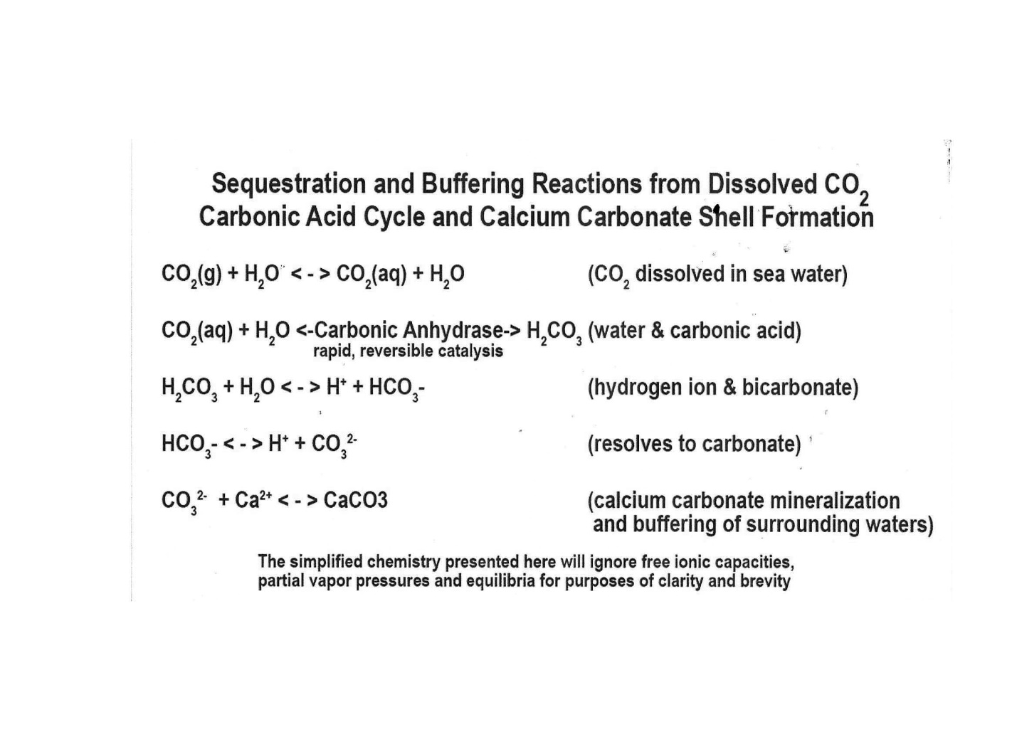
Figure 2

Carbonic Anhydrase in both alpha and beta forms, genetically encoded in E. Coli, acts as the critical catalyst, greatly increasing the effectiveness of the sequestering reaction in finally depositing Calcium Carbonate. A single zinc atom has the most important effect and placement within Carbonic Anhydrase molecules, which can alternatively be termed ‘metalloenzymes’. Indeed, even our folklore memorializes the Zinc of Gulf oysters, because optimal Zinc levels are necessary to men’s testosterone production and prostate health. In Louisiana, they say it and post it on bumper stickers ‘Eat Oysters, Love Longer’. E. Coli also lives in a mutualistic relationship with the warm-blooded mammals and birds of our world, within whose digestive tract it thrives and works to buffer against blood acidification for the whole creature. Feces of coastal predators are a primary food source for the oyster, who takes in the E. Coli, providing another relatively warm place for it to survive. E. Coli, in turn, produces the Carbonic Anhydrase which makes possible the rapid shell formation and pH buffering in which oysters excel.

The Louisiana Oyster Cultch Project (2013 – 2016) (10) estimated 200 cubic yards of shell or other cultch bedded to each acre of state seed grounds. In such a harvesting regime, landings could be calculated for final shell mass and converted to mTe at a rate of around 0.378 metric tons CO2 per yd.3 of bleached shell, which could represent 75.6 mTe total sequestration per acre. Tennessee’s ‘Pine Scenario’ project has only offered 4 mTe carbon credit per year per acre. Gulf oyster ‘shell neutral’ harvesting processes might be said to represent almost 19 times more carbon sequestration per acre than do worldwide reforestation / afforestation projects.

Oster Shell Mass per Metric Ton Equivalent C02
- 1 cubic yd Bleached Oyster Shell Weighs 1 US Ton
- 1 US Ton x .95 (Proportion of CaC03 in Oyster Shell =0.86 mT/ cubic yd
- Molar Mass C)2 = .44
Molar Mass Ca C03 = 100
Proportion of C02 in Ca C03 = 44/100 = .44
- 0.86 mTY x 0.44 (Molar Conversion Factor = 0.378 mTe C02
- 1 cubic yd Bleached Oyster Shell represents 0.378 mTe C)2 for the purpose of permanent sequestration of Carbon
Figure 3
Thus, this animal and those like him (Clams, Scallops, Snails, All Coral Reefs) not only filter the water and create an environment for all coastal life but, right under our noses, they sequester Gigatons of carbon dioxide on a massive scale. So, it becomes obvious that the destruction of the reef system over the past 300 years has had a devastating effect on the carbon cycle.

THE GOOD NEWS IS THAT CLIMATE CHNGE CAN BE REVERSED AND GIGATONS OF CO2 WILL BE PERMANENTLY REMOVED FROM THE ATMOSPHERE! UNLIKE TREES, WHICH DIE WITHIN MONTHS OR YEARS AND THEIR CARBON IN RETURNED TO THE ATMOSPHERE!

Lime-Rich Oyster Cultch Choices

• Oyster Shell & Crushed (1.5”) Oyster Shell
• Crushed Limestone • Crushed (#610) Concrete
• OysterCreteTM (Portland Cement, Fly Ash, Oyster Shell)
• Cracked Pavestones (Sand, Pea Gravel, Portland Cement)
• Cracked Brick
• Broken Cinder Block Decomposed Granite (CaO Component) & Terra Cotta (Roman Empire technology) others
MISSING
Figure 3

Louisiana State agencies have reported that natural oyster shell for planting has increased in price over the past 5 years, from roughly $15 per cubic yard (yd.3) to between $25 and $35 per cubic yard (yd.3). This has resulted in increased costs to maintain Louisiana oyster fishing grounds, public and private alike. Modern oyster culture requires water bottom management and sustainable cultch regimes so that the species can remain as both a primary food source and an important operator in the act of carbon sequestration and coastal acidification buffering. It is hoped that public and private oyster interests work toward crop sustainability in part, by claiming international carbon compliance offset profits for all the work done by our favorite seafood. At the same time, it will provide a sustainable source of protein for any animal from cattle supplement to fish food as well as food for starving millions of men, woman, and children on this planet.

Sustainability, Social License, and Environmental Justice

As stated at the beginning, this solution should be embraced by both political parties because businesses will be supported that are already operating and new businesses will be created. All of this will happen in areas of the country that were income levels are lower and fishermen are struggling as well as many in the tourist industry.
Currently, operating shellfish farms are removing 1 million tons of Carbon from the atmosphere at 10% of the capacity of the beginning of the 18th century. This is due to established oyster beds/reefs being fished out in the 18th and 19th centuries due to overfishing and dredging to harvest oysters as cheap human food for the growing cities of North America and Europe. Raw Sewage, Oil Spills, and pollution have compounded the problem. This is not just an Oyster problem but since they clean water, provide habitat, and provide food for all animals, it is a catastrophic environmental justice problem. Our team plans to employ a two-pronged Ocean approach to restore and maximize the removal of CO2. First, Ocean calcifiers form calcium carbonate in their shells using CO2 from the atmosphere (limestone). In their shells. CO2 from the atmosphere is in equilibrium with the surface Ocean. We propose to first establish foundations, enlist governments and the media and so forth so that the people and the environment will benefit. Our goal would be to establish pre-industrial production and removal of Carbon. Second, we plan to conduct a medium phase study on alkalinization of the beds/reefs to test increased calcification.

Project Location

Currently, I am in contact with key players in the Oster Industry in Texas and Louisiana. The Department of Parks and Wildlife regulates these industries, and each state has committed biologist working with the industry. Once we have funding, we will work with the biologists in each state to begin the experimental protocol to see if Oyster calcification can be increased. In fact, I am attending a Webinar tomorrow for an "Oyster Task Force Meeting" in Louisiana. I plan to copy this and then make important and relevant contacts.

Demographic Information

Demographic data shows an African American population of 59.5%, White 33.9%, Asian 2.91% Two or more races 1.92%. Louisiana as you know suffered a double blow with Covid and Katrina just being two of them, so that New Orleans has the highest poverty rate (18.6%) in the United States. Successful implementation of our team's approach will help alleviate and possibly eliminate that problem. My mother grew up without a father or mother in that area and was raised by loving sisters. When I used to visit at ages 5, the gulf was as clear as the Caribbean.

Any Additional Environmental Burden

Mostly, in my mind, the largest environmental burdens have been inadvertently imposed by the fossil fuel industry. There are many chemical plants in the area as well as offshore drilling. Recently, a proposal by President Biden to stop drilling on public lands was overturned by one judge! The beaches used to be a bright white sand along the gulf coast and now they are a grey mud flat. Birds and other wildlife have been decimated by oil spills. Giving the fishing industry money in restitution does not restore the gulf back to its former glory, it insults mother nature.

Legacy Pollution Analysis

Well, of course we have the BP oil spill which got the most headlines and, indeed, was catastrophic, but there are also smaller chemical and oil spills that occur with regular frequency along the coast. Many of these are not traceable to a capped well or to a pipeline until dead birds and fish begin washing up on the shore. Then, there is a photo op for the cleanup which consists of people in hazmat suits mopping the beach with rags. As far as I know, mopping the beach with rags has virtually no effect. Thank God that there are organisms that evolve to eat oil and plastic. The problem is that it has been incorporated in our food chain. Our worlds valid concern is that they cannot eat all the chemicals, oil, and plastic in the world's oceans until we have mass extinctions, hopefully not our own. I have beautiful granddaughter who was just accepted to college program in the 8th grade. We are so proud of her but is she going to have the same or better world to live in than I did growing up (age 75) with a Gulf of Mexico in which a person could stand on pier and see Blue Crabs in 15' of water?

Negative Environmental Impacts

As far as the drive to increase and employ the shellfish industry, the only negative environmental impact is that of fuel that is being burned by the craft that are used to gather seafood. 12,000 years ago, men lived off the Florida coast on Oysters, shrimp, crab, and fish for thousands of years without any environmental impact. They had enough shell in Southeast Florida left over to build a pyramid the size of the Pyramid of Giza. We need to incorporate clean energy into our strategy for managing these fisheries. Shore boats can be powered by batteries. Solar and other clean energies should be utilized to the maximum extent. About the experiment that involves local alkalinization, the oceans are becoming more acidic due to the increases in CO2 in the atmosphere. Dr. Rebecca Albright was able to show a 7% increase in calcification with local application of dilute le levels of sodium hydroxide (lye) on coral reefs which is why we intend to do the study. The protocol is designed to begin with levels which most simulate her study and local and frequent surveillance by trained biologists will assure that there is no negative effect.

Positive Environmental Impacts

The most important Environmental Impact will be mitigation of climate change. The reduction of C02 in the atmosphere could literally slow down the submergence of our shores which threaten to place entire cities underwater! We need to incorporate clean energy into our strategy for managing these fisheries. Shore boats can be powered by batteries. Solar and other clean energies should be utilized to the maximum extent. Regarding the experiment that involves local alkalinization, the oceans are becoming more acidic due to the increases in CO2 in the atmosphere. Dr. Rebecca Albright was able to show a 7% increase in calcification with local application of dilute le levels of sodium hydroxide (lye) on coral reefs which is why we intend to do the study. The protocol is designed to begin with levels which most simulate her study and local and frequent surveillance by trained biologists will assure that there is no negative effect.

What Steps Have We Taken to be Assured That Voices in the Community are Heard and That Their Concerns are Being Met?

I think that this could be one of the best things that could happen to this coastal community. Increased Funding will assure adequate funding of the industry and development of potential ways to produce more shell. Much of the funding should be used in a large public relations campaign which shares what is being done with the citizens of each state so that they may take advantage of the new job opportunities that will inevitably result. The effect on poverty could be profound, providing jobs, infrastructure, clean energy, food, and recreation. In Texas, a regulation was just passed to restore shell to the ocean. There shrimp and Oyster industry has been decimated to the point that the harvest had to be suspended this year. In or to help this industry recover, economies will need to be developed which gather shells from all of the Restaurants that serve Oysters. Also, they are good to eat in many other recipes beside raw oyster consumption although raw Oysters were a major food source in the past, and are now completely healthy and safe to eat, and are tested at labs at qualified labs. They are not harvested in area which could be contaminated. Also, a massive increase in production will also provide feed stock for fish farms and prevent the harvesting of smaller fish for that purpose which depletes the fisheries. Many jobs will be created as the result of billions of dollars being poured into the fishing industry, the tourist industry, and just providing food security for the world. All this, and they will also clean the water of particulates by filtering the water as they have done for millions of years.

ACTION PLAN

1. First recognize that Ocean Calcifying marine organisms remove CO2 permanently from the atmosphere. Switching to clean energy is likely to be too slow to stop climate change at the current rate of decrease in the use of fossil fuel.

2. The shell needs to be restored to the ocean floor or reef to facilitate the production of more shellfish. Otherwise, the fisheries become barren which they have. Oysters used to be abundant in New York and were a major source of food.
a. There are staggering business opportunities in collecting cultch material to spread on shellfish fisheries but there must be initial funding to stimulate the formation of these industries by the Government, NGO’s, corporations, or just Billionaires who want to reverse climate change until enough natural shell is being generated.
b. At first, other materials will need to be used to supplement shell because over the last 300 years the natural shell has been harvested resulting in barren fisheries.
c. The industry will need initial funding for expansion and production of the shellfish larvae (called spat) which can be farmed in a variety of ways including, cages, ropes, and in specified areas rotated on the bottom as would any other crop.

3. The meat from the shellfish is high quality protein high in omega-3 fatty acids and other essential vitamins and elements such as zinc which can be commercialized for a variety of uses.
a. As today, Oysters are shucked and eaten all over the world but in much smaller numbers than 300 years ago. Still, they can be fried and used for sandwiches which many people in our society have missed out on because of the price due to scarcity. Of course, clams are used in delicious pasta dishes and chowders.
b. This high-quality protein can be used for fish farming and almost every kind of protein supplement from high protein drinks, hospital total nutrition to food for cattle, chickens, and any other edible animal farmed or raised for food.

c. This solution will be essential in helping to feed the world as terrestrial farming will not be sustainable.

4. Other types of calcifying organisms such as marine algae could be farmed on a larger scale with the removal of even greater quantities of carbon and they provide food for the shellfish as well.

5. The total cost of mitigation of climate change when profits are subtracted, and taxes paid will be negligible comparted to any other form of carbon removal from the atmosphere.

6. Planting trees, although helpful and desirable, will not result in permanent removal or the same extent of removal per acre as blue carbon shellfish cultivation.

7. Funding needs to be appropriated as soon as possible to get started before it is too late to mitigate the climate change which is already in progress.
Bibliography
Figure 1-Crassostrea Virginica Gulf Oyster
Figure 2-Chemistry
Figure 3-
Moore D., Heilweck M. & Petros, P. (2021). Saving the Planet with Appropriate Biotechnology: 1. Diagnosing the Problems. Mexican Journal of Biotechnology. 6(1): 1-30. DOI: https://doi.org/10.29267/mxjb.2021.6.1.1.
Moore D., Heilweck M. & Petros, P. (2021). Saving the Planet with Appropriate Biotechnology: 2. Cultivate Shellfish to Remediate the Atmosphere. Mexican Journal of Biotechnology. 6 (1): 31-91. DOI: https://doi.org/10.29267/mxjb.2021.6.1.31.
Heilweck M. & Moore D. (2021). Saving the Planet with Appropriate Biotechnology: 3. The High Seas Solution. Mexican Journal of Biotechnology. 6 (1): 92-128. DOI: https://doi.org/10.29267/mxjb.2021.6.1.92.
Moore D. (2021). Saving the Planet with Appropriate Biotechnology: 4. Coccolithophore cultivation and deployment. Mexican Journal of Biotechnology. 6 (1): 129-155. DOI: https://doi.org/10.29267/mxjb.2021.6.1.129.
Petros, P., Heilweck, M. & Moore, D. (2021). Saving the planet with appropriate biotechnology: 5. An action plan. Mexican Journal of Biotechnology, 6 (2): 1-60. DOI: https://doi.org/10.29267/mxjb.2021.6.2.1.
PRE-PRINTS on ResearchGate:
Petros, P., Moore, D. & Heilweck, M. (2022). Planetary bioengineering on Earth to return and maintain the atmospheric carbon dioxide to pre-industrial levels: Assessing potential mechanisms. Frontiers in Astronomy and Space Sciences, in review 2 November 2021. ResearchGate preprint, DOI: https://doi.org/10.13140/RG.2.2.10773.40167.
Moore, D., Heilweck, M., Petros, P., Moore, R.J. & Squires, S.J. (2022). Calcifier Myths Dispelled: “Ocean Acidification” and “Shell Making Produces CO₂”. ResearchGate preprint, DOI: https://doi.org/10.13140/RG.2.2.20184.37128.
Moore, D., Heilweck, M. & Petros, P. (2022). Aquaculture: Ocean Blue Carbon Meets UN-SDGS. A volume in the Sustainable Development Goals Series. Published by Springer Nature Switzerland AG. ISBN: 9783030948450. 286 pp. In Press release planned for mid-April 2022. URL: https://link.springer.com/book/9783030948450 [view on Amazon].

Rosa Perfetto, Sonia Del Prete, et al Cloning, expression, and purification of the α-carbonic anhydrase from the mantle of the Mediterranean mussel, Mytilus galloprovincialis; Journal of Enzyme Inhibition and Medicinal Chemistry Volume 32, 2017 – Issue 1
Subhas AV, Adkins JF, et al Catalysis and Chemical Mechanisms of Calcite Dissolution in Seawater; Proceedings of the National Academy of Sciences, 2017 DOI: 10.1073/pnas. 1703604114
The Business of Carbon Credit Trading for Forest Landowners; Department of Forestry, Wildlife & Fisheries,UniversityofTennesseeExtensionServicePublicationhttps://extension.tennessee.edu/publications/Documents/W217.pdf
The‘GoldStandard’NGOWebsite https://www.goldstandard.org/resources/afforestationreforestation-requirements
Climate Policy Initiative, California Carbon Dashboard http://calcarbondash.org
Anne S. E. Nielsen, Andrew J. Plantinga, and Ralph J. Alig, New Cost Estimates for Carbon Sequestration Through Afforestation in the United States https://www.fs.fed.us/pnw/pubs/ pnw_gtr888.pdf https://www.ucdavis.edu/news/calcium-carbonate-and-climate-change Michele Regina Rosa Hamester; Palova Santos Balzer; Daniela Becker Characterization of calcium carbonate obtained from oyster and mussel shells and incorporation in polypropylene; Materials Research vol.15 no.2 São Carlos Mar./Apr. 2012
Thomas M. Soniat, John M. Klinck, et al A Shell-neutral Modeling Approach Yields Sustainable Oyster Harvest Estimates: A Retrospective Analysis of the Louisiana State Primary Seed Grounds; Journal of Shellfish Research, Vol. 31, No. 4, 1103–1112, 2012 10. Louisiana Natural Resource Trustees, Louisiana OysterCultchProject,revised Nov. 2014 https://www.gulfspillrestoration.noaa.gov/sites/default/files/wp-content/uploads/LA_PI_OysterCultch_Project_Monitoring-Plan_111714
Waldron, Robert Paul, B.S., B.M., M.A.: IS CRASSOSTREA VIRGINICA GULF OYSTER REEF A SUSTAINABLE RESOURCE SUBJECT TO EQUIVALENT CARBON CREDIT TRADING ON THE WORLD CAP & TRADE MARKET? Robert Paul Waldron, B.S., B.M., M.A. presented to National Shellfisheries Association ‘Aquaculture 2019’ February 2019 - New Orleans,
Dr. Rebecca Albright, Reversal of ocean acidification enhances net coral reef calcification: Nature:Vol 531:17 March, 2016
Gagern, Antioius et al, September 9th, 2019 Meeting Proceedings on Ocean Alkalinity Enhancement, current state of knowledge and potential role of philanthropy
Fears, William Burton, M.D., F.A.C.P., White Paper, Environmental Justice, Envirohomeusa.com

